 Rexburg Reader
________________________________________________________________________________________________

Crazy teens plan picnic outing

Rexburg officials were shocked today as students at the local BYU-Idaho Uni-versity announced plans for a fun, social activity, scheduled this coming Saturday eve-ning. “I think it’ll be fun,” said Jonathon Doe, a sophomore from Mesa, Ari-zona. “I hope she can go,” he said, referring to the girl he plans on asking. “This is a big step for Jonathon,” says roommate Jeffrey Davis, “but we’re all root’n him on.”
Bob Goodwright, former mayor of the town and local
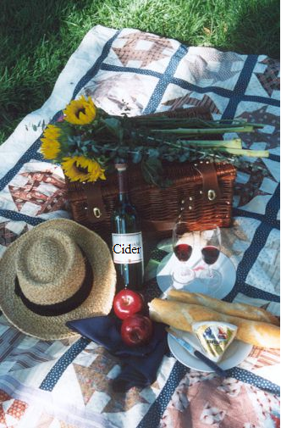
Idaho “spud” grower, cau-tions the teens to be careful, and not to raise a ruckus. “There’s no tell’in what these crazy college students will do!” he exclaims.
The activity takes place tomorrow evening at around 4 o’clock Rocky Mountain Time. Games will be played, followed by a picnic dinner. All who can attend (namely Iam Ahotdate), please contact Jonathon at 555-5555, or write to him via e-mail at Doe@dont_stalk_me.com.

Mister Potato Head strikes again, former “Spud of the Year” and young accomplice attempt to free potato pals.

Citizens of Rexburg were shocked yesterday evening as Mr. Potato Head and 9-year-old local John Brinkom attempted to raid a local farmer’s field of its potatoes before harvest season this coming winter. “It’s not right I tell you!” exclaims former “Spud of the Year” Mr. Head. (…CONTINUED ON PAGE 8.) 

